**Level 1**

Tick when completed

1. Ask the user to enter their name. Find the length of the string and output.

Hint 1



1. Ask the user to enter their postcode. Convert the postcode to uppercase and output.
2. Ask the user to enter a password. Ask the user to enter the password again for verification. Check that the two passwords match. If they match print, “Password verified”. If they do not, ask the user to enter the passwords again.

Hint 1 Hint 2

 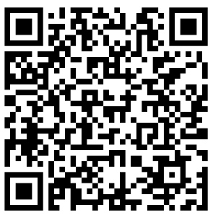

1. Ask the user to enter their first name and last name in one string. Output “Hello” followed by their last name only.

Hint 1



1. Ask the user to enter their first, middle and last names in one string. Output their initials.

Hint 1



**Level 2**

1. Ask the user to enter a saying eg “You can lead a horse to water, but you can’t force it to drink”. Output the number of words in the string.

Hint 1



1. Using a loop, print the characters of a string in reverse.

Hint 1



1. Ask the user to enter a word. Output the number of vowels and consonants in the string.

Hint 1



1. For any of the programs above, extend the program to check whether the user enters an empty string.
2. (Based on question in June 2014 exam). Write a program that asks the user to guess the six letter word “RANDOM”. The program uses iteration to compare a player’s guess to the correct word. If a letter in the player’s guess matches the letter in the same position in the correct word, the program outputs a string showing the letter in the correct position. If a letter in the player’s guess does not match the letter in the same position in the crrect word, the program outputs a string which contains a question mark at that position. For example, if the correct word were “DINNER”, and the user enters “DANGER” the program would return “D?N?ER”. The program should continue until the user guesses correctly. Any input from the user should be converted to uppercase.

**Level 3**

**Caesar Cipher** - The Caesar cipher is one of the earliest known and simplest ciphers. It is a type of substitution cipher in which each letter in the plaintext is 'shifted' a certain number of places down the alphabet. For example, with a shift of 1, A would be replaced by B, B would become C, and so on. The method is named after Julius Caesar, who apparently used it to communicate with his generals.

Write a program that produces cipher text based on a key (the number to shift letters by) chosen by the user.

Hint 1 Hint 2

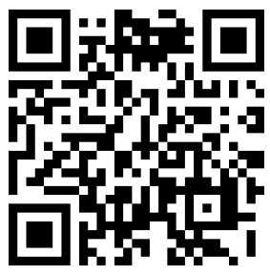              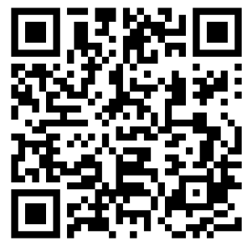

**Palindrome** – A palindrome is a word that is the same spelt forwards as backwards, eg racecar.  Write a program that detects if a string is a palindrome or not.  Do not use the reverse method if available!

**ISBN Numbers** - Books are given ISBN numbers.  These are now usually 13 digits for example, ISBN-13   978-0-349-14043-8.  The final digit is the check digit. The check digit is calculated by applying weights to each digit of the ISBN number and totalling.  The check digit will be such that the total is divisible exactly by 10. An example is shown below.

9    7    8    0    3    4    9    1    4    0    4    3    8 (checkDigit)

1    3    1    3    1    3    1    3    1    3    1    3    1

9 + 21 + 8 + 0 + 3 + 12 + 9 + 3 + 4 + 0 + 4 + 9 = 82

82 ÷ 10 = 8 remainder 2

Remainder must be zero, so check digit is 8 (82 + 8) ÷ 10 = 0.

Write a program that asks the user to input a 13 digit ISBN number.  If more than 13 digits are entered, the program should prompt the user to re-enter the ISBN number.  Note that ISBN numbers may start with 0. The program then computes whether the ISBN number is valid or not and outputs an appropriate message eg “ISBN is not valid” or “ISBN is valid”.